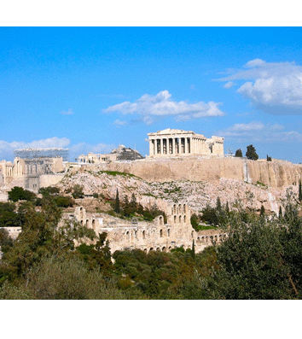 | 17th IEEE IOLTS 2011  Metropolitan Chandris Hotel  Athens, Greece  July 13-15, 2011 |  | Fill, Sign and Return this Form by Fax to:  +30 210 2515010  TRAVEL IDENTITY  Marina Kountouri

Registration Form
Advance Registration Deadline is June 12, 2011

PERSONAL INFORMATION
Last Name: |  | First Name:
Affiliation:
Address: |  | City:
Postal Code: |  | Country:
Phone: |  | Fax:
E-mail: |  | Special Meal:

FEES
IOLTS 2011 Fees | Regular 3-day Symposium |  | SUB-TOTAL
Registration Fees | ADVANCE  Until June 12 | LATE/ON-SITE  After June 12
IEEE/CS Member | ❑ 500 € | ❑ 625 €
Non Member | ❑ 650 € | ❑ 810 €
Student Member¹ | ❑ 350 € | ❑ 440 €
Student Non-Member¹ | ❑ 450 € | ❑ 560 €

Additional tickets for welcome reception | 40 € each X …… ticket (s)
Additional tickets for social event and dinner | 100 € each X …… ticket (s)
Additional tickets for 3 lunches² | 120 € each X …… ticket (s)
Additional Proceedings (Hardcopy and CD) | 50 € each X …… copy (s)
Additional pages of the camera ready paper | 75 € each X …… page (s)

IEEE Membership Number |  |  |  | TOTAL | €
Symposium registration fee includes welcome reception, social event and dinner and IEEE symposium proceedings (hardcopy and electronic).
¹ Student registration fee also includes, welcome reception, social event and dinner and IEEE symposium proceedings (hardcopy and electronic).
² For non residents at Metropolitan Chandris Hotel

PAYMENT (EUROS ONLY)
Credit card: only accepted: |  VISA |  MasterCard
|__|__|__|__|__|__|__|__|__|__|__|__|__|__|__|__| |__|__|__| |__|__| |__|__|
Card number Card Verification Code Expiration date (MM/YY)
|__|__|__|__|__|__|__|__|__|__|__|__|__|__|__|__|__|__|__|__|__|__|__|__|__|__|__|__|__|__|__|__|__|__|__|__|__|__|
Card holder´s name
I authorize TRAVEL IDENTITY to debit my credit card for the total amount of: ______________ €
Date:________________ Signature: __________________
CANCELLATION AND REIMBURSEMENT POLICY
Any cancellation made in writing to IOLTS’11 Organization and received before June 12, 2011 will entitle to the reimbursement of the amount paid after deduction of 50 € for administrative fee. No reimbursement will be granted after this date. Substitutions are free.

For any information please contact the General Co-Chair Prof. Antonis Paschalis (paschalis@di.uoa.gr)

